S. Roehrig Name:
SBI3C Date:

Assignment: Plants in the Natural Environment

PART A: KNOWLEDGE & UNDERSTANDING [29 marks]
Use the textbook (Unit 4) and/or course notes to answer the following questions:

1. What are the 4 types of plant tissue, and what is their function?
Plant tissue: | Function:
/8 KU

2. Name the two types of meristem found in plants, and describe the type of growth each is
responsible for.
Type of meristem: | Type of growth:
/4 KU

3. Label the following diagram of the cross-section of a leaf:
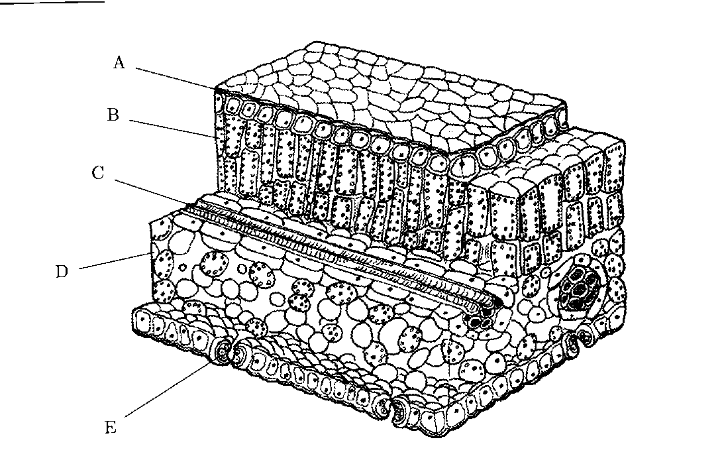
(Source: http://www.ekcsk12.org/faculty/jbuckley/apbio/plantsystemstest.html)
/5 KU
4. Complete the table with the function of each leaf structure below:
Leaf structure: | Function:
cuticle
mesophyll cells
stoma
guard cells
/4 KU
5. Write the balanced chemical equation for photosynthesis.

/2 KU

6. Name and describe the 3 types of tropisms in plants.
Name of tropism: | Change in plant growth in response to what?
/6 KU

PART B: COMMUNICATION [15 marks]
Complete the chart with the terms that match the definitions.
You will have to find the proper terms on your own

Term: | Definition:
1. | a measure of the number and abundance of different species living in a particular ecosystem
2. | a habitat dominated by a single plant species
3. | a specialized plant structure containing an embryonic plant and food supply
4. | a member of the kingdom Plantae that lacks a vascular system
5. | a member of the kingdom Plantae that has a vascular system and does not produce seeds
6. | a member of the kingdom Plantae that has a vascular system and produces naked seeds
7. | a member of the kingdom Plantae that has a vascular system and produces enclosed seeds that form within flowers
8. | an angiosperm that produces seeds containing embryos with one cotyledon (seed leaf)
9. | an angiosperm that produces seeds containing embryos with two cotyledons (seed leaves)
10. | a structure that develops from the ovary of a pollinated angiosperm, in which the seed develops
11. | vascular tissue that transports water and materials
12. | vascular tissue that transports sugars and other solutes through the plant
13. | a root system with a large central root and many smaller side branches
14. | a root system in which large numbers of relatively equal-sized roots arise from the base of the plant immediately below the ground
15. | a cell organelle found only in plant cells. It contains chlorophyll and carries out the reactions of photosynthesis. [**not in Unit 4**]
/15 C

PART C: APPLICATION [22 marks]
1. What are the three most important food plants?
-
-
-
/3 A

2. What is a "vegetable"? [1 mark] Name 2 "vegetables" that are actually fruits. [2 marks]

/3 A

3. Name 3 plant growth regulators, and briefly describe what each does.
Plant growth regulator: | Function:
/6 A

4. What is the difference between a synthetic fertilizer and a natural fertilizer? [2 marks]
Give an example of a natural fertilizer. [1 mark]
Natural Fertilizers: | Synthetic Fertilizers:
example:

/3 A

5. What are 2 reasons for banning pesticides in cities (urban environments)?
-
-
/2 A

6. What are 4 jobs that are related to working with plants?
-
-
-
-
/4 A

7. What is phytoremediation?

/1 A

PART D: THINKING & INVESTIGATION [15 marks]

1. What are 3 environmental factors that affect plant growth?
-
-
-
/3 TI
2. Choose one of the environmental factors and design your own experiment to test how that factor
affects the growth of plants. Write your design on a separate piece of paper, and make sure you
include all of the following:
-an introduction that describes the factor you are testing and your hypothesis
(If...then...because...)
-a point-form procedure for the experiment, including a list of materials and a blank
observation chart

 | Level 1(50-59%) | Level 2 (60-69%) | Level 3 (70-79%) | Level 4 (80-100%)
Statement of hypothesis:  /2 | Hypothesis has limited accuracy, clarity, and support. | Hypothesis has some accuracy, clarity, and support. | Hypothesis has considerable accuracy, clarity, and support. | Hypothesis is accurate, clearly stated, and supported.
Experimental design:  /10 | Experimental design has limited detail and effectiveness. | Experimental design has some detail and effectiveness. | Experimental design has considerable detail and effectiveness. | Experimental design includes detailed procedure and effectively tests the effect of the variable on the growth of bread mould.

/12 TI

Knowledge & Understanding TOTAL: /29 ( %)
Communication TOTAL: /15 ( %)
Application TOTAL: /22 ( %)
Thinking & Investigation TOTAL: /15 ( %)

Last day to hand in assignment: Monday June 18, 2018

