/14 C /8 T /4 A /26 total
Phases of Movement Observation Lab - VIDEO VERSION

Child 1 Age:_______________ Child 2 Age:_______________

Instructions: You will find a video of 2 different children ages 3-6 years old doing specific types of skills. You are to watch the children perform each skill and record your observations of their throwing, kicking, and developmental milestones.

1) Below is a general diagram depicting overhand throwing.
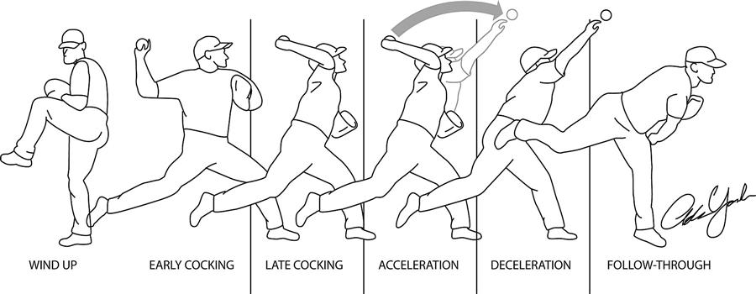

- Observe two children throwing a ball. Find two different children of similar age. Fill out the chart below describing what you saw for each phase and compare to the diagram above. [C6]
Phase | Child 1 | Child 2
Preparation
Execution
Follow Through

b) Find two different videos of children around the age of 3 catching a ball. What did you notice about the child catching the ball? Describe your observations. [C2]
Child 1:

Child 2:

2) Below is a general diagram of kicking a ball.
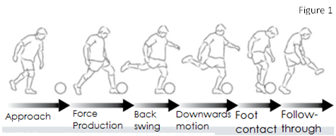

Observe two children kicking a ball. Find two different videos of children around the age of 3-6 kicking a ball. Fill out the chart below describing what you saw for each phase and compare to the diagram above. [C6]

Phase | Child 1 | Child 2
Preparation
Execution
Follow Through

3) a) Read through the Gross Motor Development Milestones Kid’s Sense article.
https://childdevelopment.com.au/resources/child-development-charts/gross-motor-developmental-chart/

List which developmental milestones each child has reached. Watch the video: https://www.youtube.com/watch?v=VkMzYj_jSGE (Child 1.).
Also watch and observe child 2:
https://www.youtube.com/watch?v=FhqBuSXeKyw (2 years old).
. Ex. At age 3, children should be able to jump in place with two feet. [TI4]

Child 1 milestones:
→
→
→
→

Child 2 milestones:
→
→
→
→

b) Now try to determine which milestones the child has yet to reach. Ex. At age 4, children should be able to walk on a line. Try and find two different videos of two different 4 year olds trying to walk on a line. If they cannot, they have not reached this milestone yet. [TI4]

Child 1 milestones not yet reached. Did they reach this milestone?:
→
→
→
→

Child 2 milestones not yet reached. Did they reach this milestone?:
→
→
→
→

4) What fundamental movement skills did you observe today?
List two examples (FMS category AND the name of the skill) from each child that you observed on the videos. [4A]

